**Electron Arrangements, Ionic and Covalent Bonds**

Electrons are arranged in specific energy shells around the nucleus of the atom. Here are the electron arrangements of 4 very common atoms found in organic molecules:

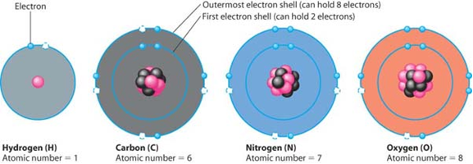

How many electrons can the first energy shell hold? ___ The second energy shell? ________

To be chemically stable, atoms react with other atoms in order to achieve _____ ____________.

Here is the atomic structure of first 3 rows of the periodic table:

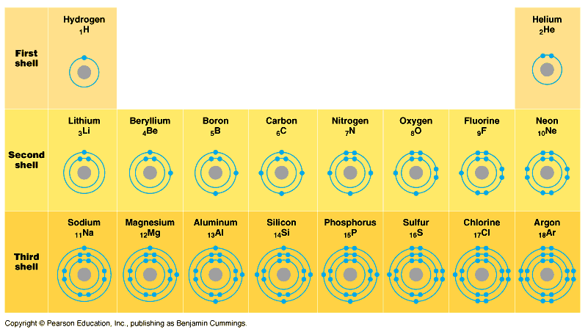

By looking at the periodic table, you can determine how many electrons each element will gain or lose in order to achieve stability. For example, how many electrons will magnesium lose in order to have a complete outer electron shell? _____ How many electrons will nitrogen gain in order to have a complete outer electron shell? ___

In chemical reactions, atoms react in order to achieve a complete outer electron shell.

If electrons are **transferred** between atoms in order to achieve complete outer shells, the result is an ______________ bond, held together by the attraction between ____ and ___ ions.

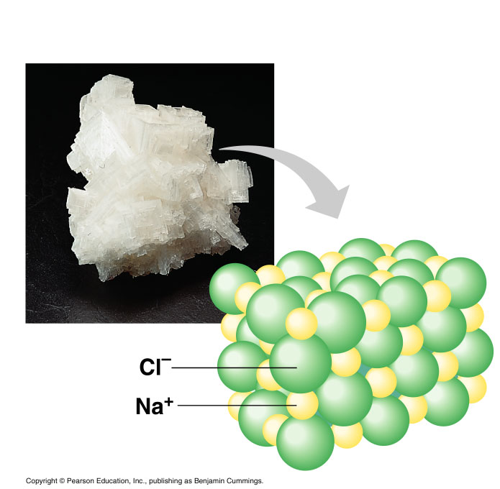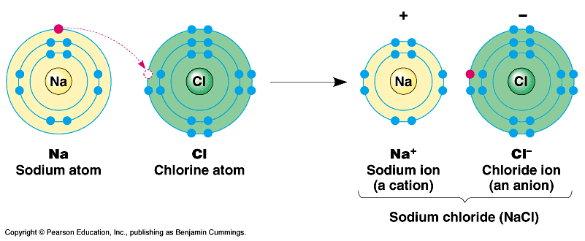

Sodium chloride (table salt) is a good example of an ionic compound:If electrons are **shared** in order to achieve complete outer shells, the chemical bond is described as a __________________________ bond. The resulting structures are called ‘molecules’. Here are some sample covalently-bonded molecules:

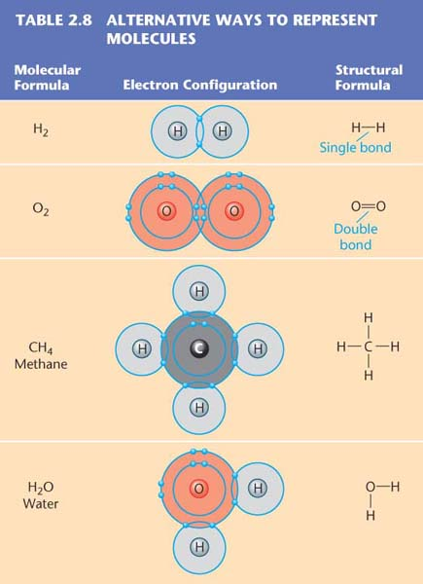

If two pairs of electrons are shared between atoms, the result is called a ___________________ bond. If three pairs of electrons are shared between atoms, the result is a ______________ bond.