Chemistry 11
Final Exam Review
Tuesday, June 13, 2017

NOMENCLATURE
- Write names or chemical formulae for
  - Ionic compounds
  - Covalent compounds
  - Hydrates
  - Acids and bases

- Write the correct formula for the following compounds:

a) ammonium chlorate _________________________________
b) copper (II) sulphite _________________________________
c) zinc carbonate tetrahydrate _________________________________

d) nitric acid _________________________________

e) phosphorus pentaiodide _________________________________

f) iron (III) thiocyanate _________________________________

g) sulphuric acid _________________________________

h) chlorous acid _________________________________

- Write the correct names for the following compounds:

a) Mn(SO₄)₂ ___________________________________________________
b) PbCrO₄ . 6H₂O ___________________________________________________
c) As₂O₃ ___________________________________________________

d) CH₃COOH ___________________________________________________

e) Ni₂(C₂O₄)₃ ___________________________________________________

f) NF₃ ___________________________________________________

g) (NH₄)₂HPO₄ ___________________________________________________

h) Ba(OH)₂ . 10H₂O ___________________________________________________

CHEMICAL REACTIONS
- Open and closed systems and the conservation laws
- Writing and balancing chemical equations with proper phases
- Types of reactants: synthesis, decomposition, single replacement, double replacement, combustion, neutralization
- Predicting products of reactions
- Energy changes in a reaction: endothermic vs. exothermic
- Diatomic elements

- Balance the following equations.
- NH₃ + O₂ NO + H₂O
- (NH₄)₂C₂O₄ + AlCl₃ Al₂(C₂O₄)₃ + NH₄Cl
- C₁₄H₃₀ + O₂ CO₂ + H₂O
- Fe + HNO₃ Fe(NO₃)₃ + H₂
- P₄ + Cl₂ PCl₃
- Na₂Cr₂O₇ + HCl NaCl + CrCl₃ + H₂O + Cl₂
- H₃PO₄ + Ca(OH)₂ Ca₃(PO₄)₂ + H₂O
- Ba(ClO₄)₂ Ba + Cl₂ + O₂
- C₇H₁₅OH + O₂ CO₂ + H₂O
- MgSO₄ . 5H₂O MgSO₄ + H₂O

- Write a balanced chemical equation for each of the following, and classify each as synthesis, decomposition, single replacement, double replacement, neutralization or combustion.

a) potassium sulphate is mixed with cobalt (III) nitrate

b) liquid propanol (C₃H₇OH) is burned in air

c) ammonium nitrate is decomposed into it’s elements

d) a piece of zinc is placed in a test-tube containing a solution of silver nitrate

e) bromine reacts with sodium iodide

f) bromine reacts with aluminum

g) rubidium reacts with chlorine gas

h) hydrochloric acid reacts with strontium hydroxide

- State whether each of the following are exothermic or endothermic.

- ___________________________ HCl + 432 kJ H⁺ + Cl⁻
- ___________________________C₁₂H₂₂O₁₁ + 12 O₂ 12CO₂ + 11H₂O ΔH = -5638 kJ
- ___________________________ H₂O_{(s)} H₂O_{(l)}
- ___________________________ CD C + D ΔH= 65.7 kJ
- ___________________________ E + F + 437 kJ G + H
- ___________________________ I_{(g)} → I_{(s)}
- Sketch a potential energy diagram for an exothermic reaction between Zn and HCl. Lable the axes, reactants, products, and change in enthalpy on the graph.

- State whether the following are true for exothermic or endothermic reactions.

- ____________Heat is released into the surroundings | - ____________The reaction flask becomes cold
- Heat is absorbed into the system | - ____________Heat is released by the system
- ____________Heat is absorbed by the surroundings | - ____________The reaction flask becomes hot
- ____________A bright light emits from the reaction | - ____________The reaction is violent and spontaneous
- ____________Energy is flowing from the surroundings into the system

PHYSICAL PROPERTIES AND CHANGES
- Classification of matter: homogeneous, heterogeneous, pure substance, mixtures (solution, suspension, mechanical mixture)
- Separation and purification techniques
  - Hand separation
  - Filtration
  - Distillation
  - Evaporation
  - Solvent extraction
  - Recrystallization
  - Gravity separation
  - Chromatography
- Heating curves

- Write P for physical property and C for chemical property for the properties of water below.

- _______ Water has a density of 1.0 g/mL
- _______ Water is colourless
- _______ Water boils at 100°C
- _______ Water generates H₂ gas when in contact with an alkali metal
- _______ Water freezes at 0°C
- _______ Water is insoluble with oil
- _______ Water with metal oxides will generate a base

- Explain how distillation works to separate substances. What kind of mixtures can be distilled?

- Explain how gravity separation works and what kind of mixtures it can be used for.

- Explain how to separate and isolate a mixture of sand, sugar, water, and alcohol.

- Given the following graph of Temperature vs. Time for warming substance “X” which starts out as a solid, describe what is happening at each time interval. Be sure to include the terms intermolecular forces and kinetic energy. Label the diagram with phase transitions and melting and boiling points.

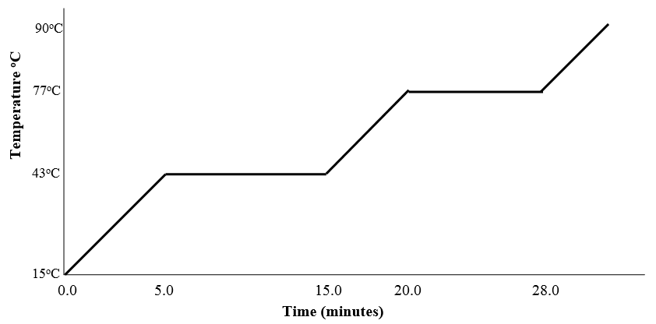

  - During time 0.0 – 5.0 minutes

  - During time 5.0 – 15.0 minutes

  - During time 15.0 – 20.0 minutes

  - During time 20.0 – 28.0 minutes

  - The melting point of substance “X” is _____________and the boiling point is _____________

  - If a greater amount of substance “X” was used, the melting point would be
    - a lower temperature
    - a higher temperature
    - the same temperature

  - What phase is substance “X” at 90°C? ______________________________
- Explain how chromatography works for identification of components in a mixture.

- What is the physical changed called when

- ____________________________ solid to gas
- ____________________________ liquid to solid
- ____________________________ solid to liquid
- ____________________________ gas to liquid
- ____________________________ gas to solid
- ____________________________ liquid to gas

SIGNIFICANT FIGURES AND MEASUREMENTS
- What are the SI units
- Unit conversion
- Metric prefixes
- Accuracy vs. precision
- Significant figures
- How to read a scale

- What is the SI unit for time? __________ Mass in chemistry? __________ Volume? __________

- How many significant figures are in the following numbers?
- 4.500 |  | - 0.005
- 300.0 |  | - 0.00300
- 10 |  | - 10100

- Convert the following to scientific notation while maintaining the number of significant numbers in the original value.
- 0.00000977 |  | - 194000000
- 988.540000 |  | - 0.000500

- Round the following numbers to two significant figures.
- 2 000 000 000 |  | - 3.8894 x 10²⁸
- 106 000 |  | - 0.000 000 7895

- What kind of values do not carry significant figures?

- Perform the following calculations with proper significant figures.

- 2.1500 x 0.31 | - 83.00 ÷ 1.2300 x 102
- 8.90 x 103 ÷ 4.400 x 10⁻⁶ | - 4.905 x 106 ÷ 4 x 10⁻²
- 0.05 + 394.7322 | - 98.0076 - 2.195
- (3.33 x 9.52) + 13.983 | - 0.00000200 x 245.912
- 3.813 + 98.98 + 2.669 | - 5.802 ÷ 6.21 + 2.41 ÷ 9.2565

- A student was measuring the density of water. She found that 100.0 mL of water had a mass of 94.04 g. Given that the density of water is 1.0000 g/mL, what is the relative error of her measurement?

- How do you find the uncertainty of a reading from a scale?

- Read the following scales. Include the uncertainty in the measurement, then give the range of values your measurement could be.

- ____________________________  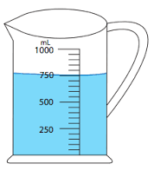 | - ____________________________  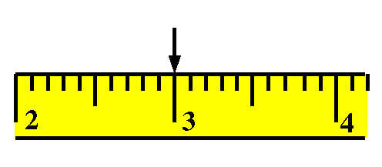
- ____________________________  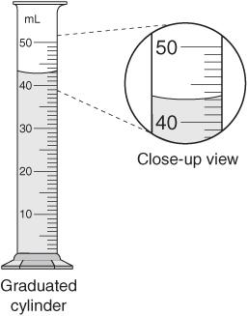 | - ____________________________  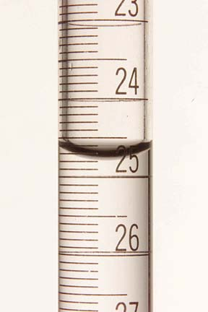

- Darts are thrown onto a dart board. Assess whether each outcome for precision and accuracy.
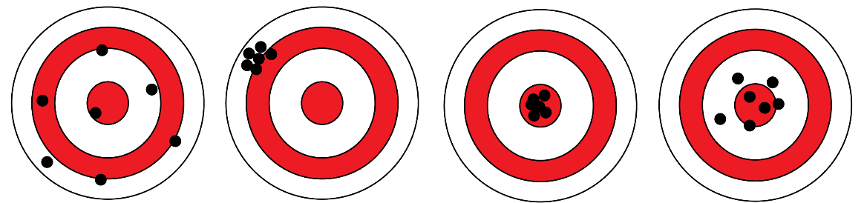

- In a lab, what does it mean if your results are precise, but inaccurate?

- Convert the following with proper significant figures.

 | - 9.0 ng to μg | - 0.045 cm to km
 | - 25.5 mL to L | - 0.33 kg to mg
 | - 54 μg/L to g/mL | - 2.5 cm³ to m³
THE MOLE
- Know and use Avogadro’s number
- What is a mole
- What is atomic mass, molar mass
- Mole calculations with mass, density, percents, STP
- How to find the empirical formula and molecular formula

- Make the following conversions, clearly showing your steps. Include proper units in all of your work and in your answer.

  - 133.44 grams of PCl₅ = ? moles

  - 0.00256 moles of Li₂Cr₂O₇ = ? grams

  - 170.24 L of NO₂ at STP = ? moles

  - 570.625 g of PCl₃ gas = ? L (STP)

  - 1030.4 mL of C₂H₆ gas at STP = ? g

  - 5.00 kg of nitrogen gas = ? L (STP)

  - 0.5696 kg of CH_{4(g)} = ? mL (STP)

  - 9.8 g of NH₃ = ? molecules

  - How many atoms of Cl are there in 5.55 g of PCl₅?

  - How much does a billion molecules of sugar, C₆H₁₂O₆, weigh?

- The density of liquid ethanol C₂H₅OH is 0.790 g/mL. Calculate the number of molecules in a 35.0 mL sample of liquid ethanol.

- A 100.0 mL sample of liquid mercury contains 6.78 moles. Calculate the density of liquid mercury from this data.

- Calculate the density of PCl_{3(g)} at STP.

- The density of a gas at STP is 4.955 g/L.

- Calculate the molar mass of this gas.

- The gas is an oxide of selenium. Determine the molecular formula.

- Find the percent composition in Sr₃(PO₄)₂.

- What mass of Ca(OH)₂ can be made from 5.00 grams of Ca?

- How many grams of cobalt (II) chloride hexahydrate can be made with 10.0 g of the anhydrous salt?

- A compound was analyzed and the following results were obtained:

Molar mass: 270.4 g/mol
Mass of sample: 162.24 g
Mass of potassium: 46.92 g
Mass of sulphur: 38.52 g
Mass of oxygen: the remainder of the sample is oxygen

- Determine the mass of oxygen in the sample.

- Determine the empirical formula for this compound.

- A compound has the empirical formula of CHO. Name 3 molecular formulas that have CHO as their empirical formula.

- 3.36 g of C, 0.708 g of H and 2.24 g of O combine to form 0.0702 moles of compound. What are its empirical and molecular formulas?

- What are the empirical formulas of the following compounds?

- compound 1: 25.8% oxygen by mass, the rest is sodium.

- compound 2: 28.2% potassium, 25.6% chlorine and 46.2% oxygen.

- A compound is 42.9% C, 7.1% H and 50.0%N. It has a molar mass of 140 g/mole. What is its molecular formula?

- 10.0 grams of a compound containing C, H and N is burned in oxygen. 16.28 grams of CO₂ and 3.34 grams of water are produced. When a sample of the compound is compared to the same volume of Neon gas at the same temperature and pressure, it is found to be 6.75 times heavier. What is the molecular formula of the compound?

- What is the empirical formula for a compound which contains only C, H, and O if the combustion of 0.255 g yields 0.561 g of CO₂ and 0.306 g of H₂O?

STOICHIOMETRY
- Calculate mass, moles, number of particles of one species given the data for another in a chemical equation
- Find the excess and limiting reagents in a reaction
- Find the percent yield of a reaction
- Predict amount of reactant or product in a reaction knowing its percent yield
- Explain factors that lead to a percent yield less than 100%, and greater than 100%

- Given the equation C₁₂H₂₂O₁₁ + 12O₂ 12CO₂ + 11H₂O + 5638 kJ which occurs at STP

- How many grams of C₁₂H₂₂O₁₁ is required to produce 50.0 g of CO₂?

- How much heat is released during the formation of 880.0 g of CO₂?

- How much heat is released during the formation of 5.6 moles of H₂O?

- If 179.2 L of O₂ are consumed, how much heat is released?

- How many litres of CO₂ will be produced if 30.0 g of O₂ were used?

- How many moles of CO₂ are produced from the burning of 16 g of CH₃OH according to the unbalanced reaction below?
CH₃OH + O₂ CO₂ + H₂O

- Consider the following unbalanced reaction at STP:

Fe_{(s)} + H₂O_{(l)} Fe₃O_{4(aq)} + H_{2(g)}

- What is the number of moles of H₂O needed by the reaction to form 3 moles of Fe₃O₄?

- How many grams of Fe are needed to make 6.0 g of H₂?

- What mass of iron would be needed to fill a 1.5 litre balloon with hydrogen?

- How many molecules of Fe₃O₄ will be produced from 5.00 g of Fe?

- C₂H₂ burns completely in O₂ to produce CO₂ and H₂O at STP.

- If 7500 L of C₂H₂ are completely burned in excess oxygen, how many litres of CO₂ at STP could be produced?

- What volume of C₂H₂ at STP is needed to produce 56.0 g of water?

- Consider the decomposition of water: H₂O H₂ + O₂. What is the number of moles of O₂ produced by the decomposition of 90. g of H₂O?

- How many grams of CO₂ are produced by burning 0.400 moles of C₄H₁₀ in excess oxygen?

- N₂ and H₂ react to form NH₃.

- How many litres of N₂ are required to produce 60 litres of NH₃?

- How many litres of N₂ are needed to react with 30 litres of H₂?

- Potassium sulfite reacts with phosphoric acid to give potassium phosphate and sulfurous acid.

- 32.66 g of potassium sulfite and 14.74 g of phosphoric acid are reacted. Find the limiting reagent.

- What is the mass of sulfurous acid and potassium phosphate that forms?

- Consider the following unbalanced reaction.

Fe₂(CO₃)₃ + CaCl₂ FeCl₃ + CaCO₃

- 8.76 g of Fe₂(CO₃)₃ and 9.546 g of CaCl₂ were mixed. What is the limiting reagent?

- What mass of FeCl₃ forms?

- How many moles of CaCO₃ form?

- How many grams of the excess reagent will be left over after the reaction is done?

- 25.0 g of barium chloride and 25.0 g of potassium sulphate are reacted. What mass of barium sulfate forms?

- An impure sample of zinc has a mass of 1.50 g. All of the zinc in the impure sample is converted into zinc oxide which was found to have a mass of 1.59 g. What is the percentage of zinc in the impure sample?

- You wish to prepare as much magnesium acetate, Mg(CH₃COO)₂, as you can. You have 10.0 g of MgCrO₄ and 15.0 g of MgSO₄. Which reaction will yield more Mg(CH₃COO)₂?

- Ammonia burns in oxygen according to the following reaction:

NH₃ + O₂ NO₂ + H₂O

50.0 g of ammonia is reacted with 100.0 g of oxygen. How much NO₂ will be produced?

- The cylinders of a car have a volume of 6.15 litres. Assuming that air fills this volume at STP and is 21% oxygen, what mass of octane (C₈H₁₈) would be needed to combine with the oxygen?

- What is the percent yield if 67.6 g of product was obtained for a reaction that theoretically should have produced 80. g?

- A reaction is done using 59.2 g of Cu₂S and 47.8 L of O₂ at STP to give Cu₂O and SO₂. If 26.1 g of Cu₂O is produced, calculate the percent yield.

- A scientist wishes to synthesize Fe₂(SO₄)₃ using the following reaction:

3CuSO₄ + 2Fe Fe₂(SO₄)₃ + 3Cu

How much CuSO₄ should he use to make 125.0 g of Fe₂(SO₄)₃ if the reaction has a 65.0% yield?

GAS LAWS
- Describe pressure, volume, and temperature and how they relate to one another
- Convert between different units for pressure (atm, torr, kPa, bar, mmHg) and temperature (°C vs K)
- Apply the Ideal Gas Law, Charles’s Law, Boyle’s Law, and the Combined Gas Law

- Fill in the blanks with the following words, which can be used more than once:

less more directly inversely increase(s) decrease(s) slow down speed up

As temperature increases, gaseous particles ______________________ and exert ______________________ force on their container. This causes a(n) ______________________ in pressure. If the container is flexible, this causes a(n) ______________________ in volume. As temperature decreases, gaseous particles ______________________ and exert ______________________ force on their container. This causes a(n) ______________________ in pressure. If the container is flexible, this causes a(n) ______________________ in volume. Temperature is said to be ______________________ related to pressure and ______________________ related to volume. Volume is ______________________ related to pressure.

- Convert the following pressures and temperatures.

- 56 kPa to atm | - 5 mmHg to atm
- 30°C to K | - 101 Torr to kPa
- 200. atm to kpa | - 19 K to °C

- What does STP stand for and what conditions does it represent?

- Find the pressure inside a 5.0 L glass bulb filled with 5.0 mol of He at 25°C.

- What is the volume 3.5 moles of gas at -55°C and 350. mmHg?

- 0.025 moles of a gas at 101 atm occupies 6.3 mL of space. Find the temperature of this gas in °C.

- 25 g of iodine is sublimated at 32°C into a 500.0 mL flask. Find the pressure inside the flask.

- What mass of C₂H₆ at 45 kPa and 25°C contains the same number of molecules as 15 g of CH₄ at 125 kPa and 0.0°C?

- A gas at 45°C and 98 mmHg occupies 5.6 L of space. What would its volume be at STP?

- A certain gas at 500. mL exerts 250 kPa in a canister with a piston. The piston is lowered to squeeze the gas to 120 kPa. What is the volume of the canister?

- 3.0 mol of gas in a syringe set to 25 mL at 10°C exerts 98 atm. If the syringe is pulled to 55 mL, what will the new pressure be?

- A gas is collected at 35°C and occupies 2.5 L. The storage tank available for this gas is only 500.0 mL. What temperature should this gas be stored at in order to use the 500.0 mL tank?

- What is the new temperature of a gas that is compressed from 35 L at 25°C to 12 L?

- A gas at 0°C is heated to 100°. How much will the volume increase as a result of this heating?

- 500.0 liters of a gas are prepared at 700.0 mm Hg and 200.0 °C. The gas is placed into a tank under high pressure. When the tank cools to 20.0 °C, the pressure of the gas is 30.0 atm. What is the volume of the gas?

- At conditions of 785.0 Torr of pressure and 15.0 °C temperature, a gas occupies a volume of 45.5 mL. What will be the volume of the same gas at 745.0 Torr and 30.0 °C?

- A gas balloon has a volume of 106.0 liters when the temperature is 45.0 °C and the pressure is 740.0 mm of mercury. What will its volume be at 20.0 °C and 780 .0 mm of mercury pressure?

- 73.0 mL of nitrogen at STP is heated to 80.0 °C and the volume increase to 4.53 L. What is the new pressure?

- The pressure of a gas is reduced from 1200.0 mm Hg to 850.0 mm Hg as the volume of its container is increased by moving a piston from 85.0 mL to 350.0 mL. What would the final temperature be if the original temperature was 90.0 °C?

- A 500. mL tank contains 2.0 g of He, Ne, and Ar gas at 30.°C. What is the partial pressure of each gas in the tank?

- A canister contains 25 g of CO₂, CH₄, and O₂. The total pressure is 650 kPa. What is the partial pressure of each gas?

- A flask contains a mixture of 2.0 g of CH₄ and 3.0 g N₂. If the pressure in the flask is 60.0 atm, what is the partial pressure of each gas?

- A chamber contains 0.25 mol O₂, 0.35 mol of N₂, and 0.45 mol of CO₂. When all the N₂ is removed, the pressure of the system drops by 35 kPa. What is the partial pressure of each gas and the total pressure?

- Hydrogen sulfide reacts with sulfur dioxide to produce water and solid sulfur. How many litres of hydrogen sulfide is needed in order to produce 100.0 g of solid sulfur in a reaction at 25°C and 97 atm?

- Some zinc was dropped in hydrochloric acid to produce hydrogen gas. The gas produced inflated a balloon to 6.0 L at 22°C and 98.1 atm. How much zinc was used?

ATOMIC THEORY
- Describe atoms using nuclear notation
- Describe what an isotope is
- Draw and interpret Bohr diagrams, and explain its flaws
- Describe the major contributions of Democritus, Dalton, Thomson, Rutherford, Bohr, and Shrodinger
- Describe the atomic orbitals
- Write the electron configuration for neutral and charged atoms with and without an energy level diagram. Know the exceptions.
- Count the number of valence electrons
- Describe the periodic families
- Describe the periodic trends: atomic radii, electronegativity, ionization energy, reactivity
- Describe the 3 types of bonds: ionic, covalent, polar covalent
- Assess polarity of a bond and assign partial charges
- Draw Lewis structures for neutral and charged molecules, including those with resonance
- Describe how bond length and electronegativity affect bond strength in ionic and covalent compounds

- Consider the following ideas:
- Compounds are made up of molecules which are combinations of atoms
- All atoms of an element are the same
- Atoms of different elements are different
- Atoms are indivisible particles

Who came up with these ideas? ______________________

- ___________________________ measured the charge/mass ratio of an electron and came up with the so-called “plum pudding” model of the atom.

- ___________________________ devised the Gold Foil Experiment, which showed that all atoms had a small dense __________________________.

- Bohr came up with an atomic model to explain ______________________________________________.
He said that the atom has certain _______________ levels which are allowed. If an electron absorbs a certain amount of energy, it will jump to a ___________________ level. It will release this energy (in the form of a __________________) when it jumps back to a ______________ level. Bohr’s model was revolutionary at his time, but has since then been proven to be flawed in two major ways: __________________________________________________________________________________________________________________________________________________________________________

- Fill in the following table.

Nuclear Symbol | Protons | Neutrons | Electrons | Mass Number | Charge
$${}_{77}^{194}{{Ir}^{3+}}$$
$${}_{80}^{202}{{Hg}^{2+}}$$
$${}_{52}^{125}{{Te}^{2-}}$$
$${}_{106}^{263}{{Sg}^{}}$$
$${}_{1}^{2}{H^{+}}$$
 | 105 |  |  | 262 | 2+
 | 51 | 72 | 48
 |  | 42 | 36 |  | 3-
 |  | 79 | 54 | 133
 | 94 | 150 |  |  | 3+

- Element “X” is composed of the following naturally occurring isotopes:

Isotope | % Abundance
X-79 | 50.69
X-81 | 49.31

- Calculate the average atomic mass of element “X” to 3 decimal places.

- What is Element X? ______________

- Regions in space occupied by electrons are called ___________________________. Sketch the four types.

- Fill the energy level diagram for phosphorous.

- How many shells have electrons? _______
- How many sub-shells have electrons? _______
- How many orbitals have a single electron? _______
- How many orbitals have paired electrons? _______

- Write the electron configuration for the following atoms in full and core notation.
- P
- Mo
- Se
- Rb
- Cl⁻
- Al³⁺
- K⁺
- S²⁻

- How many valence electrons are in Mg? ______ F? _______ S? ________ Ti? ________ Zn? ________

- Circle the metalloid: Be Rb Os Ge Pb Al

- Circle the most reactive element in the following: Na Mg Si Al Ar

- Circle the most reactive element in the following: Na K Rb Cs Li

- Circle the most reactive element in the following: Cl Br I At Ne

- Circle the element with the largest atomic radius of these: Na Mg Si Al Ar

- Circle the element with the largest atomic radius of these: N P As Sb Bi

- Circle the element with the largest ionization energy of these: K Ca Ga As Kr

- Circle the element with the largest ionization energy of these: C Si Ge Sn Pb

- Circle the element with the smallest atomic radius: Mg Mg²⁺ Be Be²⁺

- Circle the element with the highest electronegativity of these: Mg Si S Cl

- Circle the element with the highest electronegativity of these: F Cl Br I

- Circle the most metallic element of these: Be Mg Ca Sr Ba

- Circle the element with the largest atomic radius: F Cl Br⁻ Se

- Circle the most metallic element of these: Ga Ge Se Br Kr

- Circle the compound you’d expect to have the highest melting point: NaCl NaF

- Circle the compound you’d expect to have the highest melting point: MgO MgS MgCl₂

- In an ionic bond, electrons are
  - shared equally by two atoms
  - shared unequally by two atoms
  - transferred from a metal to a non-metal
  - transferred from a non-metal to a metal
  - closer to one end of a molecule, forming a temporary dipole

- In a covalent bond, electrons are
- shared equally by two atoms
- shared unequally by two atoms
- transferred from a metal to a non-metal
- transferred from a non-metal to a metal
- closer to one end of a molecule, forming a temporary dipole

- In a polar covalent bond, electrons are
- shared equally by two atoms
- shared unequally by two atoms
- transferred from a metal to a non-metal
- transferred from a non-metal to a metal
- closer to one end of a molecule, forming a temporary dipole
- Match each descriptor with its chemical family.

- Alkali metal | ________ These elements have a valence of 8 or 0
- Alkaline earth metal | ________ These elements form +2 ions
- Transition metals | ________ These elements have both metal and non-metal properties
- Metalloids | ________ These elements are soft, silver, and shiny
- Halogens | ________ These elements are coloured and multivalent
- Noble gases | ________ These elements are diatomic and poisonous

- If a bond were to be made between the following pairs of elements, the result would be covalent (C), polar covalent (PC), or ionic (I)?

- ________ O and O | - ________ S and O | - ________ F and N
- ________ Mg and Cl | - ________ B and Si | - ________ P and S

- Draw Lewis structures for the following:

- MgCl₂ | - PBr₃ | - SeF₂
- CH₃CH₂I | - SF₂ | - NSH
- SiS₂ | - CHF₃ | - PCl₅
- COF₂ | - SH₆ | - N₂

- One structure for NO₃⁻ is shown. Draw the other resonance structures.
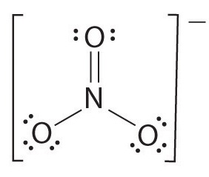

- On the following molecule, draw the symbol for bond dipole for all bonds and assign partial charges.

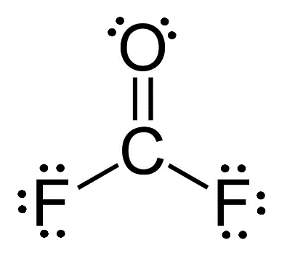

VSEPR THEORY AND SOLUTION CHEMISTRY
- Explain VSEPR theory
- Predict the 3D shapes and bond angles of molecules
- Describe the intermolecular forces (dipole-dipole, London, H-bonds) and how they differ from intramolecular forces (ionic, polar covalent, covalent)
- Explain how substances dissolve and predict solubility in different solvents
- Write dissociation reactions
- Calculate molar concentrations using mass and volume
- Calculate ion concentrations after dilutions, mixing solutions, precipitation
- Predict the solubility of compounds using the Solubility Chart
- Write formula, complete ionic, and net ionic equations
- Predict the conductivity of various solutions

- What is meant by molar concentration or molarity?

- 123.11 g of zinc nitrate are dissolved in enough water to form 650.0 mL of solution. Calculate the molarity of the solution.

- Calculate the mass of potassium sulphite needed to make 800.0 mL of a 0.200 M solution.
- What volume of 2.50 M Li₂CO₃ would need to be evaporated in order to obtain 47.232 g of solid Li₂CO₃?

- You add 50.0 mL of a 2.0 M Na₂CO₃ solution to a reaction. How many grams did you add?

- Draw and name VSEPR structures for the following and determine whether they are polar.

- MgCl₂ | - PBr₃ | - SeF₂
- CH₃CH₂I (Challenge) | - SF₂ | - NSH
- SiS₂ | - CHF₃ | - PCl₅
- COF₂ | - SH₆ | - N₂

- A molecule is said to be polar if ___________________________________________________________

- What are the three intramolecular forces? __________________________________________________

- What are the three intermolecular forces? __________________________________________________

- Which is stronger, intramolecular forces or intermolecular forces?

- For ionic compounds, which force is involved in melting, intramolecular or intermolecular?

- For covalent compounds, which force is involved in boiling, intramolecular or intermolecular?

- Of the intermolecular forces, which is the strongest? ___________________

- Analyze the following molecules for the presence of intermolecular bonds.

 | H-bonds | Dipole-dipole | London Forces
- CH₂F₂
- CH₃CH₂CH₃
- CH₃CH₂OH
- SF₆
- PH₄F

- Which of the compound(s) from the previous question would you expect to have the lowest boiling point? Explain.

- Circle the most conductive: Fe_{(s)} NaCl_{(s)} CH₃OH_{(aq)}

- Circle the most conductive: 1.0 M NaCl 1.2 M LiF 0.5 M MgCl₂

- Circle the most conductive: KF_{(s)} KF_{(aq)} CH_{4(l)}

- Given the following reaction

MgCO_{3 (s)} + 2HCl _{(aq)} CO₂ _{(g)} + H₂O _{(l)} + MgCl_{2(aq)}

What mass of MgCO₃ will react completely with 15.0 mL of 1.5 M HCl?

- Calculate the volume of 2.0 M HCl which would be needed to react completely with 37.935 grams of magnesium carbonate.

- In a titration, 18.20 mL of 0.300 M Ba(OH)₂ is required to react completely with a 25.0 mL sample of a solution of HNO₃. Find the [HNO₃].

- In a titration, 11.06 mL of 0.200 M HNO₃ is required to react completely with a sample of 0.250M Ba(OH)₂ . Find the volume of the Ba(OH)₂ sample.
- 150.0 mL of water are added to 400.0 mL of 0.45 M HNO₃. Calculate the final [HNO₃].

- What volume of water needs to be added to 150.0 mL of 4.00 M H₂SO₄ in order to bring the concentration down to 2.50 M?

- Give directions on how to make 5.00 L of 0.020 M Ca(ClO)₂ using solid Ca(ClO)₂ and water.

- 200.0 mL of 2.0 M Na₂SO₄ is mixed with 300.0 mL of 1.5 M NaNO₃. Find the final concentration of all ions.

- 25.5 mL of 3.0 M Na₃PO₄ is mixed with 40.0 mL of 2.0 M Ca(NO₃)₂.

- Will there be a precipitate? If yes, what will it be? _______________________

- Write the formula equation.

- Write the complete ionic equation.

- Write the net ionic equation.

- Find the final concentration of each ion.

- Describe how to make 200. mL of a 0.65 M solution of LiI

- How many grams of CaCl₂ are contained in 1.25 L of a 0.25 M solution of CaCl₂?

- What is the molarity of a solution made from dissolving 15.6 g of CaI₂ into 1900 mL of water?

- 14.5 g of calcium chloride and 13.76 g of aluminum chloride are dissolved in order to make a solution that is 2.5 L. What is the chloride ion concentration in the final solution?

- 2.5 L of a 0.96 M solution of Li₂CO₃ are added to 3.0 L of water. What are the final concentrations of the Li⁺ and CO₃²⁻ ions after mixing?

- What volume of 1.37 M sucrose can be made from 300 mL solution that is 2.7 M sucrose?

- What are the concentrations of each of the ions of AlCl₃ as 1.40 L of a 0.45 M solution is concentrated to 0.23 L?

- What are the final concentrations of all ions when 2.5 L of 1.56 M AgNO₃ is mixed with 1.9 L of 1.36 M KCl?

- 200.0 mL of 1.60 M aluminum bromide is mixed with 3.0 L of 1.40 M barium bromide. What is the final bromide ion concentration?

- FeCl_{3(aq)} is mixed with Sr(OH)₂. Write out the molecular, complete ionic and net ionic equations for the reaction.

- 0.967 L of 0.90 M FeCl₂ is mixed with 1.10 L of 1.10 M Na₂S. What are the concentrations of all of the ions after mixing, and what mass of precipitate forms?

- Circle the best solvent for LiF: CH₃OH CH₃OCH₃ HCl

- Circle the best solvent for NSH CH₃CH₂CH₃ HF CH₃CH₂F

- Circle the best solvent for CH₃CH₂CH₃: H₂O cyclohexane HNO₃

- Circle the best solvent for Mg(OH)₂: methanol propanol butanol

ORGANIC CHEMISTRY
- Interpret/draw condensed structures and line diagrams from molecular formulae and organic names for
  - Alkanes, alkenes (including cis and trans), alkynes
  - Branched and cyclic structures
  - Alkyl halides
  - Alcohols
  - Ketones
  - Aldehydes
  - Carboxylic acids
  - Esters
  - Ethers
  - Amines
  - Amides
- Identify various functional groups
- Predict the products or reactants for an esterification reaction

- Name and draw the following molecules.

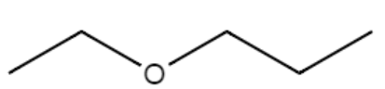 | - 2-butyne
- 3,3-diethylheptanoic acid | 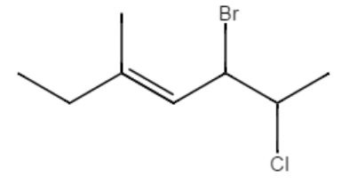
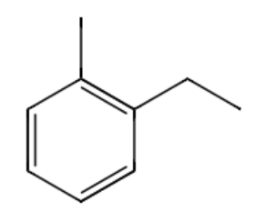 | 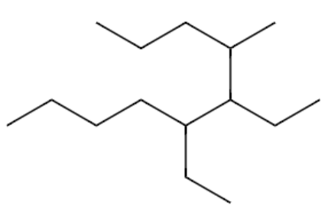
- methyl pentanoate | 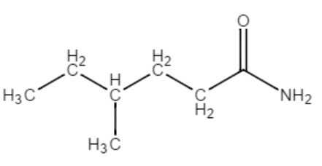
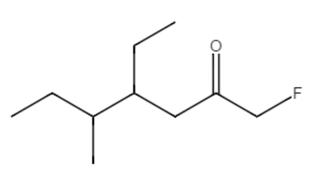 | 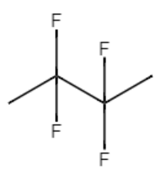
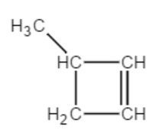 | 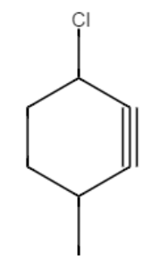
- aminobenzene | - 2,3,3-trichloropentanal
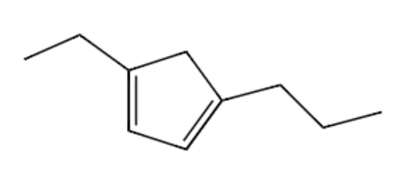 | - 3-methyl-4-phenyl-1-pentyne
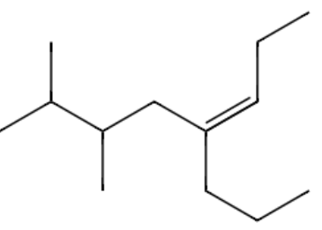 | - trans,cis-8-methyl-3,5-nonadiene
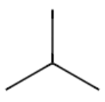 | 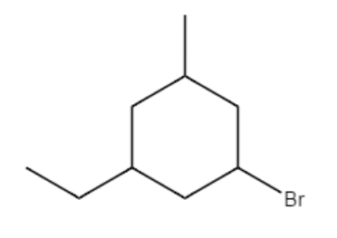

- Match the following descriptors with the correct functional group or organic structure.

- Saturated hydrocarbon | ________ A halogen branch
- Aromatic compound | ________ Would turn litmus paper red
- Alkyl group | ________ Have cis and trans isomers
- Alkenes | ________ Alkanes are also known as this
- Alkynes | ________ Are an anesthetics
- Alcohols | ________ Any branch that contains carbons and hydrogens
- Ketones | ________ Have a linear 180°C section
- Aldehydes | ________ Names end in “-one”
- Esters | ________ Can be made from carboxylic acids with alcohol
- Ethers | ________ Have an amino group next to a carbonyl
- Amines | ________ Smells fishy
- Amides | ________ A C = O group
- Carboxylic acids | ________ Compounds that are poisonous and have a strong odor
- Carbonyl group | ________ Benzene is an example
- Alkyl halide | ________ A carbonyl group at the first carbon
- Convert these line diagrams to condensed structures.

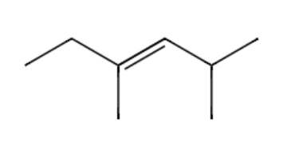

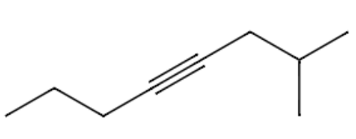

- What are isomers?

- Why are cyclic alkanes not an isomer of their non-cyclic alkane counterparts? For example, why is cyclobutane not an isomer of C₄H₁₀?

- Predict the product or reactant structures for each esterification.

- methanol + ethanoic acid ?
- 2-butanol + 2-methylpropanoic acid ?
- Cyclohexanol + 2,3-dimethylbutanoic acid ?
