Warming Behaviour of Solid Paradichlorobenzene

!! SAFETY PRECAUTIONS !!
- the hot plate gets extremely hot
- heat paradichlorobenzene slowly to avoid shattered glass
- paradichlorobenzene is toxic

Purpose

- To observe what happens when solid paradichlorobenzene is warmed to 70°C
- To graph the heating and cooling curve of paradichlorobenzene
- To determine the melting point of paradichlorobenzene

Background

Paradichlorobenzene is used to control moths, moulds, and mildew. It is also used as a disinfectant. The compound accumulates in fat tissue and is environmentally hazardous.

H
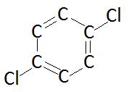
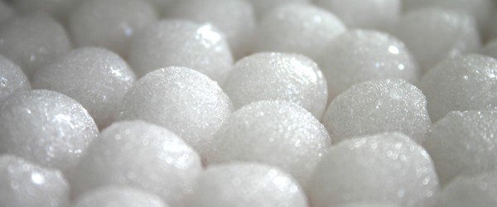
H
H
H

Materials

Equipment  - 500 mL beaker  - 100 mL Erlenmeyer flask  - hot plate  - test tube  - thermometer  - ring stand  - test tube clamp  - timer | Reagents  - paradichlorobenzene

Procedure:

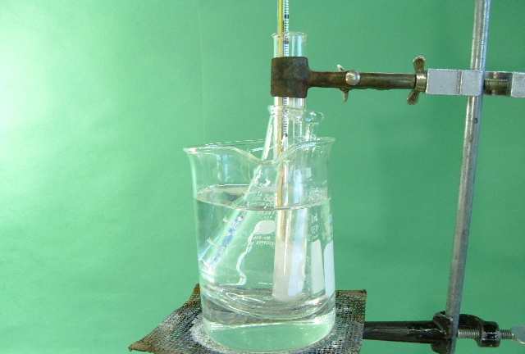
- Get a 500 mL beaker and fill it about half full of tap water to make a hot water bath. Place it on a hot plate and begin heating.

- Put a 100 mL Erlenmeyer flask into the beaker.

- Obtain a test tube with solid paradichlorobenzene and a thermometer in it. Use a test tube clamp to attach this to the ring stand. Put the ring stand next to the hot plate.

- When the water bath is hot, lower the test tube clamp to lower the test tube into the Erlenmeyer flask. Record the initial temperature.

- Record the temperature every half minute until the temperature is above 70ºC. At this point, turn off the hot plate, and adjust the test tube clamp to lift and swing the test tube with the thermometer away from the hot water bath to begin cooling.

- Record the temperature every half minute until the temperature reaches room temperature.

Results

- Using Excel, plot the heating and cooling curves of paradichlorobenzene using your data.
- Title your graph as “Heating & Cooling Curve of Paradichlorobenzene” (1 mark).
- Label the axes with Temperature (ºC) and Time (min) (1 mark):
- Using your data, plot each point on your graph (1 mark).
- Draw a smooth curve through the data points. If some points are not on the curve, draw a best fit line or omit the point (1 mark).
- Label the melting point on your graph (1 mark).
- Label on your graph where paradichlorobenzene is a solid and liquid (1 marks).
- Label on your graph where paradichlorobenzene is changing from solid to liquid (1 mark).

Discussion

- What is happening to the molecules at the plateau of the graph? (1 mark).
- What is happening to the molecules at the slopes of the graph? (1 mark).
- Predict what the graph would look like if you continued to heat the liquid paradichlorobenzene well past its melting point. Sketch the graph and label the following:
- Phase transitions (1 mark).
- Where paradichlorobenzene is solid, liquid, and gas (1 mark).
- Boiling point and melting point (include the temperature) (2 marks).
- Predict what the graph would look like if you started from gaseous paradichlorobenzene and waited for it to solidify. Sketch the graph and label the following:
- Phase transitions (1 mark).
- Where paradichlorobenzene is solid, liquid, and gas (1 mark).
- Condensation point and freezing point (include the temperature) (2 marks).

