**Lab 8.1 - Preparation of Esters**

**Introduction**

Esters are a group of organic compounds best known for their interesting odors and flavors. Many natural odors and flavors were discovered to be esters and therefore, many synthesized esters are used in perfumes and foods.



An ester has the functional group R-COO-R’ , or which is also known as an ester link. In the laboratory, an ester is usually formed from the reaction of a carboxylic (organic) acid and an alcohol, giving an ester and water as the products. This is an example of a condensation reaction, in which two molecules link up by the elimination of a small molecule between them; in this case, water.



We can write a general equation for the formation of esters as follows:

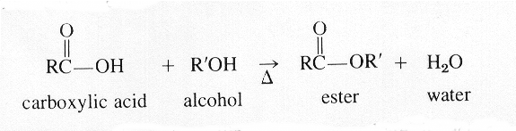

Here, R and R’ represent any alkyl group, of general formula CnH2n+1. Examples would be

methyl (CH3-), ethyl (C2H5-), or propyl (C3H7-).R and R’ can also represent any aryl group

(one that contains a benzene ring) such as phenyl (C6H5-).

The first part of the name of an ester is derived from the alkyl or aryl group of the alcohol used and the second part is from the carboxylic acid, using the ending -oate. As an example, if ethyl alcohol (ethanol)

combines with propanoic acid, the resulting ester is named ethyl propanoate.

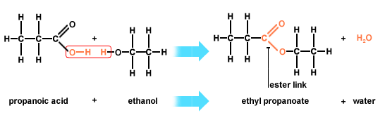

The aroma of oranges is attributed to octyl ethanoate (formed from octanol and ethanoic acid) and apricots have an aroma because of the presence of pentyl butanoate (formed from pentanol and

butanoic acid).

The reaction between the alcohol and acid is rather slow at room temperature. In order to

speed it up and get an appreciable yield in the time available, you will use a temperature of

about 60°C and add sulfuric acid to act as a catalyst in the reaction. In this experiment, you

will prepare a variety of esters and carefully smell them to see if there are any odors you recognize.

**Purpose**

1. To synthesize several esters and try to identify the odor of each.

2. To write the chemical equations for the formation of each ester using structural formulas.

**Materials**

6 test tubes

Water soluble marker

Test tube rack

Eye dropper

Scale

Hot plate

2 x 250 mL beakers

10 mL graduated cylinder

Thermometer

Lab apron

Safety goggles

Methanol

Ethanol

Glacial acetic acid

Formic acid

Salicylic acid

1-propanol

Butyric acid/butanoic acid

Concentrated sulfuric acid

**Procedure**

1. Put on your lab apron and safety goggles.

2. Label the six test tubes 1 to 6 with your water soluble marker and place them in the test tube rack.

3. Into the appropriate test tube, pour the correct amount of alcohol and add the corresponding carboxylic acid as indicated in Table 1 below (use the scale to measure the solid salicylic acid). Add 4 drops of concentrated sulfuric acid to each test tube.

Table 8.1 –Reagents for preparation of esters

Carboxylic Acid and Alcohol

1)1 mL acetic acid and 1 mL 1-propanol

2) 1 g salicylic acid and 1 mL methanol

3) 1 mL butanoic acid and 1 mL ethanol

4) 1 mL formic acid and 1 mL ethanol

4. Pour about 150 mL of tap water in the 250 mL beaker. Place the test tubes in the water and heat the water on a hot plate to a temperature of about 60°C. Leave the test tubes in the hot water bath for 15 minutes.

5. Cool the test tubes by immersing them in cold water in another beaker.

6. Add 5 mL of distilled water to each of the test tubes.

7. Carefully note the odor of the contents of each of the test tubes in a table. Hold the test tube about 30 cm away from your nose and gently waft the vapors towards your nose without inhaling deeply. Each of the odors should be somewhat familiar to you.

8. Dispose of all materials in the waste bucket.

9. Wash all glassware, and your hands thoroughly with soap and water.

**Observations**

Table 8.2 – Odours of Esters

|  |  |  |
| --- | --- | --- |
| Test Tube | Name of Ester | Odour |
|  |  |  |
|  |  |  |
|  |  |  |
|  |  |  |

**Questions**

1. Using structural formulas, write the equations for the reactions that occurred in each of

the test tubes.

2. Name the ester formed in each of the test tubes and complete the ‘Odours of Ester chart’