Problem Set 7.4 - Electron Configuration
Key Points:
- Bohr stated that electrons can only occupy certain distinct (quantified) energy levels. We refer to these energy levels as orbitals.
- Quantum means a district quantity of energy. Each electron has a quantum number which refers to its location.
- Refer to the following 3-D images of s,p,d,f orbitals to help you visualize as you learn - https://www.youtube.com/watch?v=K-jNgq16jEY
Electron Configuration
Each element has a specific electron configuration defining where the electrons are located. In order to understand the location of electrons, we must now look at the atom in three dimensions rather than the planetary early model of the atom. The orbitals are not two dimensional tracks like railroads circling an atom, but are rather areas of three dimensional space where we expect to find the electron. These shapes are still called orbitals, and we can describe their location and nature using quantum numbers.
Quantum Numbers
Each electron has a quantum number, or location defined by: n l #
The principal quantum number (n) indicates the relative size of the orbital (ex. 1-7). A shell is made up of all orbitals with the same ‘n’ value. ex. (2s and 2p).
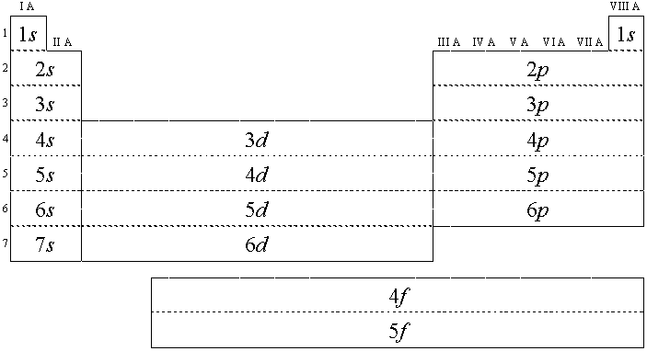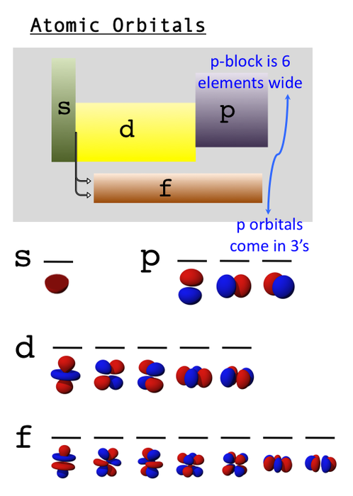

The second quantum number (l) is called the angular momentum quantum number and refers to the shape of the orbital (ex. s=0,p=1,d=2,f=3). A subshell refers to a set of orbitals of the same type (ex. p orbitals)
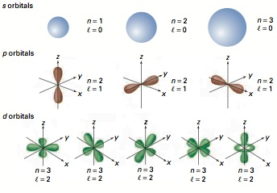
The # tells us how many electrons are in that particular orbital. The maximum number of electrons in each type of orbital corresponds with the layout of the periodic table (ex. S – 2; P – 6; D- 10; F – 14)
To determine the electron configuration, we must fill in the following order and obey the principles below:
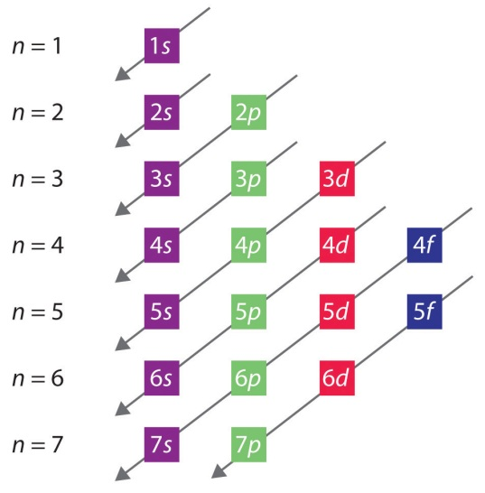
The Pauli Exclusion Principle
No two electrons in the same atom can be described by the same set of quantum numbers.

The Aufbau Principle
When filling orbitals, the lowest energy orbitals are filled first.

Practice Problems:
- Li 2. Si
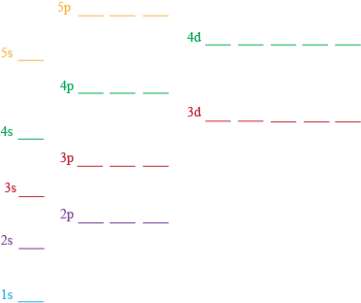
__________________________________ __________________________________
3. Y 4. Cu

__________________________________ __________________________________
Core Notation: (state the noble gas directly before the element in square brackets, then list the quantum numbers of the valence electrons only).
a. Cl: ______________________________ b. Al: ___________________________________

Ion Notation: (remove from the highest energy electrons first)
c. Ca ²⁺ ______________________________ d. Na ⁺ Core: _______________________

Complete p. 283-284 #7-11

