Titrations Practice Worksheet
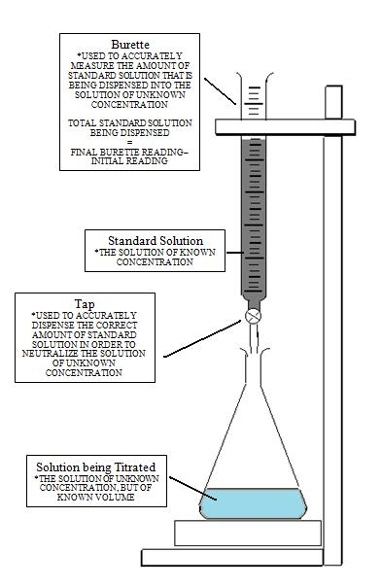

A titration is a quantitative analysis used to determine the concentration of an unknown solution, by reacting and neutralizing it with another solution of known concentration. Because we can determine the stoichiometric ratios of neutralization, we can use this information to calculate the number of moles of our unknown substance.

The equivalence point occurs when the solutions neutralize each other, and the [H⁺] = [OH⁻]. The endpoint occurs when the indicator changes colour (not always exactly the same as the equivalence point, ex. phenolphthalein changes colour at pH 8.2, not 7.0).

Practice Problems:

1) The data from a titration of 15mL of a 1.5M solution of Ba(OH)₂ with an unknown concentration of HCl (aq) is shown below. Determine the concentration of the HCl.
 | Trial 1 | Trial 2 | Trial 3
Final | 7.0 | 14.9 | 21.8
Initial | 0.0 | 7.0 | 14.9
Total

2) If it takes 25 mL of 0.05 M HCl to neutralize 345 mL of NaOH solution, what is the concentration of the NaOH solution?

Homework: Workbook pg. 399 #1,2,5,9,10

