Unit 8 Review : Organic Nomenclature Review

1. Match the name to the structure by writing the correct number on the arrow beside the drawings.
2. Scratch out any names which are incorrect (not accurate naming).
3. Draw the remaining structures.

|  |  |  |
| --- | --- | --- |
| 1. 3-hexanol 2. 2-hexanol 3. 4,4-diethyl-1-pentene 4. cyclopentanol 5. butanoic acid 6. cyclopentene 7. 3 – ethyl – 4 – propylnonane 8. 2-methylbutane 9. 1,3 - hexadiene 10. 2,2-dimethylbutane | 1. 4 – methyl – 2 – hexyne 2. heptyl-butyl ether 3. 2-butyne 4. pentane 5. 2-hexanone 6. 1-bromo – 2 chloro pentane 7. 2-butanol 8. 3,5-dimethyl octanoic acid 9. 2-isopropyl-4-ethyl hexanoic acid | 1. 3 - methyl – 2,3 – pentadiol 2. 3-hexanone 3. 4 – ethylheptane 4. 4,4-diethyl-heptanal 5. cyclopropane 6. 3 - methylhexane 7. 2,4 – dimethylhexane 8. cyclopropyne 9. 3 – ethylcyclohexene 10. 2,3 – nonadiene |

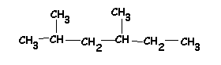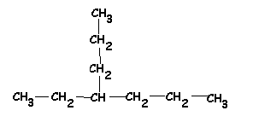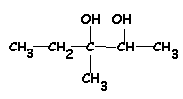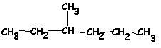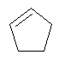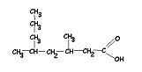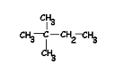

Answers :



Remaining Structures :